# 

# 

# 

# **Maths Methods 11**

# **2019 Investigation 2**

# **Take Home**

# 

# **Trigonometric Equations and Identities**

**NAME: _______________________________ Teacher:**

## Part I

1. Graph 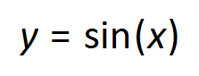 and 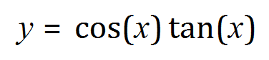over the domain 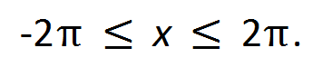Graph the curves on separate grids using the same range and scale. What do you notice?

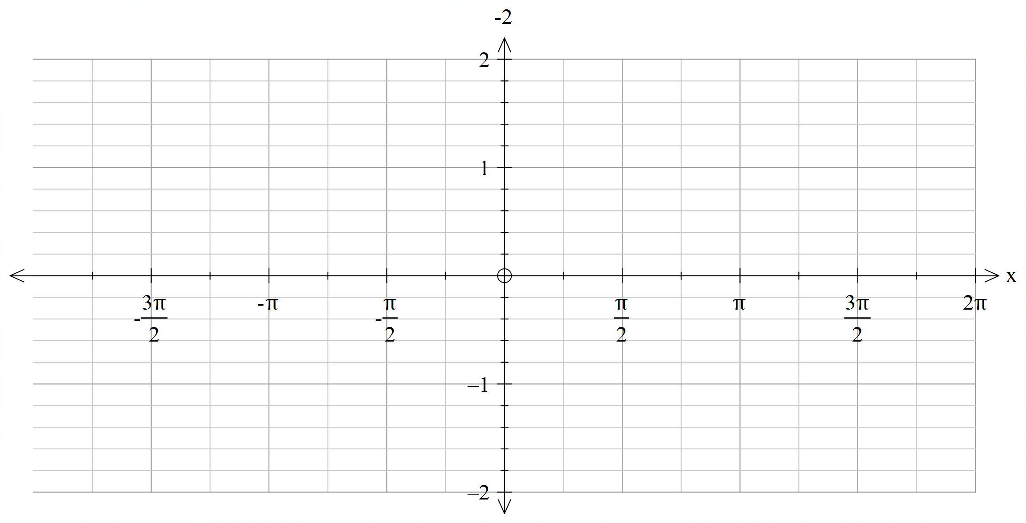



1. Make and analyse a table of values for these functions in multiples of 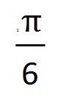 over the domain Describe your findings.
2. By examining both the graphs and the table of values, justify whether or not the functions are identical.
3. For what values of x will the expressions 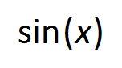 and 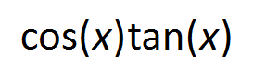 over the given domain, will not be not equal?

## Part II

1. Consider the equation 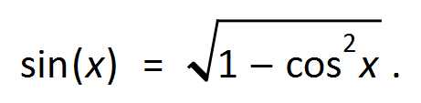
2. Identify a value for 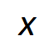 that will make the equation true.
3. Identify a value for  that does not work for the equation above.
4. Hence provide 2 reasons why the equation above is not an identity.

## Part III

Using your results from Part I and Part II, explain the difference between a Trigonometric Equation from an Identity.